Muhammad Arham
L1F23BSSE0372
public class Calculator_Cp {
static int add(int a, int b) {
return a + b;
}
// Red Phase - Tests
static void testAddPositiveNumbers() {
int result = add(3, 5);
if (result == 8) {
System.out.println("Test 1 - Add Positive Numbers : PASS ");
} else {
System.out.println("Test 1 - Add Positive Numbers : FAIL Expected 8 but got " + result);
}
}
static void testAddWithZero() {
int result = add(0, 7);
if (result == 7) {
System.out.println("Test 2 - Add With Zero : PASS");
} else {
System.out.println("Test 2 - Add With Zero : FAIL Expected 7 but got " + result);
}
}
static void testAddNegativeNumbers() {
int result = add(-2, -3);
if (result == -5) {
System.out.println("Test 3 - Add Negative Numbers : PASS ");
} else {
System.out.println("Test 3 - Add Negative Numbers : FAIL Expected -5 but got " + result);
}
}
static void testAddMixedNumbers() {
int result = add(-3, 7);
if (result == 4) {
System.out.println("Test 4 - Add Mixed Numbers : PASS ");
} else {
System.out.println("Test 4 - Add Mixed Numbers : FAIL Expected 4 but got " + result);
}
}
public static void main(String[] args) {
System.out.println(" TDD - Simple Calculator ");
testAddPositiveNumbers();
testAddWithZero();
testAddNegativeNumbers();
testAddMixedNumbers();
System.out.println(" All Tests Completed ");
}
}

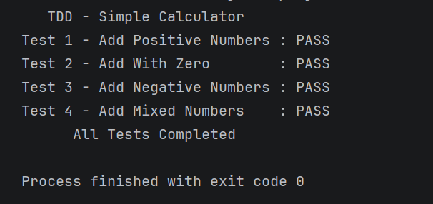

Task 2
public class BankAccount_Cp {
// Bank Account Logic
private double balance;
// Constructor
public BankAccount_Cp(double initialBalance) {
this.balance = initialBalance;
}
// Deposit Method
public double deposit(double amount) {
balance += amount;
return balance;
}
// Withdraw Method
public double withdraw(double amount) {
if (amount > balance) {
System.out.println("Insufficient funds!");
return balance;
}
balance -= amount;
return balance;
}
// Get Balance Method
public double getBalance() {
return balance;
}
// @Before - Setup (runs before each test)
static BankAccount_Cp setUp() {
return new BankAccount_Cp(1000.0);
}
// Test 1: Normal Case - Deposit Amount
static void testDeposit() {
// Arrange
BankAccount_Cp account = setUp();
// Act
double result = account.deposit(500.0);
// Assert
System.out.println("Test 1 - Deposit Amount : " + (result == 1500.0 ? "PASS " : "FAIL "));
}
// Test 2: Normal Case - Withdraw Amount
static void testWithdraw() {
// Arrange
BankAccount_Cp account = setUp();
// Act
double result = account.withdraw(200.0);
// Assert
System.out.println("Test 2 - Withdraw Amount : " + (result == 800.0 ? "PASS " : "FAIL "));
}
// Test 3: Edge Case - Withdraw Exact Balance
static void testWithdrawExactBalance() {
// Arrange
BankAccount_Cp account = setUp();
// Act
double result = account.withdraw(1000.0);
// Assert
System.out.println("Test 3 - Withdraw Exact Bal : " + (result == 0.0 ? "PASS " : "FAIL "));
}
// Test 4: Invalid Case - Withdraw More Than Balance
static void testWithdrawInsufficientFunds() {
// Arrange
BankAccount_Cp account = setUp();
// Act
double result = account.withdraw(5000.0);
// Assert
System.out.println("Test 4 - Insufficient Funds : " + (result == 1000.0 ? "PASS " : "FAIL "));
}
// Test 5: Edge Case - Check Balance
static void testGetBalance() {
// Arrange
BankAccount_Cp account = setUp();
// Act
double result = account.getBalance();
// Assert
System.out.println("Test 5 - Check Balance : " + (result == 1000.0 ? "PASS " : "FAIL "));
}
public static void main(String[] args) {
System.out.println(" TDD - Bank Account System ");
testDeposit();
testWithdraw();
testWithdrawExactBalance();
testWithdrawInsufficientFunds();
testGetBalance();
System.out.println(" All Tests Completed ");
}
}

Output:
